Give below details

**IP address :** 182.156213.202

**Port range :** 7001 to 7032 ( will be given by your batch mentor)

**User name :** b1 ( will be given by your batch mentor)

**Password :**  Set@1234 (will be given by your batch mentor)

To edit user name ,click on Show Options

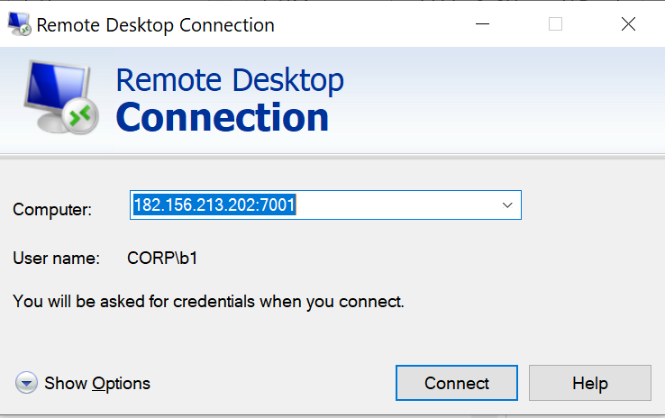

Give the username as CORP\b1 and click on connect.

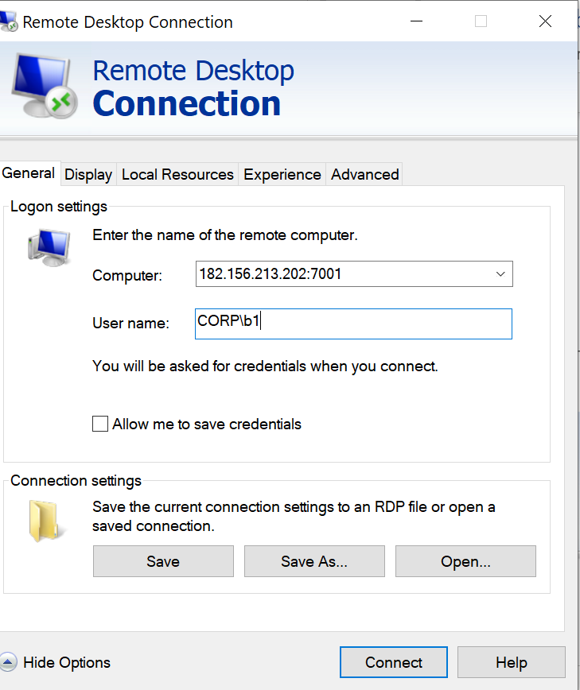

In the remote system, all the necessary s/w will be available in the path C: \IMS Soft